# Django REST API

## Create new project

* Cmd activate environment

1. *(python36) C:\Users\abhijith.m\0 zerone\Django>django-admin startproject withoutrest*
2. *(python36) C:\Users\abhijith.m\0 zerone\Django>cd withoutrest*
3. *(python36) C:\Users\abhijith.m\0 zerone\Django\withoutrest>python manage.py startapp testapp*

* (testapp/views.py)>

from django.shortcuts import render

from django.http import HttpResponse

# Create your views here.

def emp_data_view(request):

emp_data = {

'eno':100,

'ename':'Sunny',

'esal': 10000,

'eaddr': 'Mumbai',

}

resp = 'Employee Number:{}Employee Name:{}\

Employee Salary:{}Employee Address:{}'.format(emp_data['eno'],

emp_data['ename'],

emp_data['esal'],

emp_data['eaddr'])

return HttpResponse(resp)

* (withoutrest/urls.py)>

from django.contrib import admin

from django.urls import path

from testapp import views

urlpatterns = [

path('admin/', admin.site.urls),

path('api/', views.emp_data_view),

]

* Runserver
  + *(python36) C:\Users\abhijith.m\0 zerone\Django\withoutrest>python manage.py runserver*
  + <http://127.0.0.1:8000/api>
* (testapp/views.py)> add

import json

def emp_data_jsonview(request):

emp_data = {

'eno':100,

'ename':'Sunny',

'esal': 10000,

'eaddr': 'Mumbai',

}

resp = json.dumps(emp_data)

return HttpResponse(resp, content_type='application/json')

* (withoutrest/urls.py)> add

path('apijs/', views.emp_data_jsonview),

* <http://127.0.0.1:8000/apijs/>
* Cmd http client
  + *(python36) C:\Users\abhijith.m\0 zerone\Django\withoutrest>pip install httpie*
  + *(python36) C:\Users\abhijith.m\0 zerone\Django\withoutrest>http* [*http://127.0.0.1:8000/apijs/*](http://127.0.0.1:8000/apijs/)

HTTP/1.1 200 OK

Content-Length: 64

Content-Type: application/json

Date: Thu, 18 Jul 2019 12:42:52 GMT

Server: WSGIServer/0.2 CPython/3.6.8

X-Frame-Options: SAMEORIGIN

{

"eaddr": "Mumbai",

"ename": "Sunny",

"eno": 100,

"esal": 10000

}

* Json response without converting dict to json
* (testapp/views.py)> add

from django.http import JsonResponse

def emp_data_jsonview2(request):

emp_data = {

'eno':100,

'ename':'Sunny',

'esal': 10000,

'eaddr': 'Mumbai',

}

return JsonResponse(emp_data)

* (withoutrest/urls.py)> add

path('apijs2/', views.emp_data_jsonview2),

* Create file ‘test.py’ in any other location other than project directory

import requests

import json

BASE_URL = 'http://127.0.0.1:8000/'

ENDPOINT = 'apijs'

resp = requests.get(BASE_URL+ENDPOINT)

print(resp.json())

* Run test.py file

## Generic view

* (testapp/views.py)> add

from django.views.generic import View

class jsonCBV(View):

def get(self, request, *args, **kwargs):

emp_data={

'eno':100,

'ename': 'Sunny',

'esal':1000,

'eaddr':'Mumbai',

}

return JsonResponse(emp_data)

* (withoutrest/urls.py)> add

path('apijscbv/', views.jsonCBV.as_view()),

* In browser <http://127.0.0.1:8000/apijscbv/>
* (testapp/views.py)> update

from django.views.generic import View

class jsonCBV(View):

def get(self, request, *args, **kwargs):

json_data = json.dumps({'msg':'This is from get method'})

return HttpResponse(json_data, content_type='application/json')

def post(self, request, *args, **kwargs):

json_data = json.dumps({'msg':'This is from post method'})

return HttpResponse(json_data, content_type='application/json')

def put(self, request, *args, **kwargs):

json_data = json.dumps({'msg':'This is from put method'})

return HttpResponse(json_data, content_type='application/json')

def delete(self, request, *args, **kwargs):

json_data = json.dumps({'msg':'This is from delete method'})

return HttpResponse(json_data, content_type='application/json')

* Test.py

import requests

import json

BASE_URL = 'http://127.0.0.1:8000/'

ENDPOINT = 'apijscbv'

resp = requests.post(BASE_URL+ENDPOINT)

print(resp.json())

* It should return an error msg. because the csrf token is not defined.
* The middleware setting reject this request
* (withoutrest/settings.py)> inside ‘MIDDLEWARE’ >
* Comment the following line

# 'django.middleware.csrf.CsrfViewMiddleware',

* Test.py request ‘’resp = requests.delete(BASE_URL+ENDPOINT)’’

### Basics of arguments

def f1(**kwargs):

print(kwargs)

f1(name='abhi', rollno=100, mark=90)

{'name': 'abhi', 'rollno': 100, 'mark': 90}

def f1(*args):

print(args)

f1()

f1(90)

f1(90,20,30)

()

(90,)

(90, 20, 30)

### Mixin

* (testapp/)> create file mixins.py

from django.http import HttpResponse

class HttpResponseMixin(object):

def render_to_http_response(self, json_data):

#1000 lines of code

return HttpResponse(json_data, content_type='application/json')

* (testapp/views.py)> update

from django.views.generic import View

from testapp.mixins import HttpResponseMixin

class jsonCBV(HttpResponseMixin, View):

def get(self, request, *args, **kwargs):

json_data = json.dumps({'msg':'This is from get method'})

return self.render_to_http_response(json_data)

def post(self, request, *args, **kwargs):

json_data = json.dumps({'msg':'This is from post method'})

return self.render_to_http_response(json_data)

def put(self, request, *args, **kwargs):

json_data = json.dumps({'msg':'This is from put method'})

return self.render_to_http_response(json_data)

def delete(self, request, *args, **kwargs):

json_data = json.dumps({'msg':'This is from delete method'})

return self.render_to_http_response(json_data)

## CRUD without REST framework

* In cmd

1. *(python36) C:\Users\abhijith.m\0 zerone\Django>django-admin startproject withoutrestm*
2. *(python36) C:\Users\abhijith.m\0 zerone\Django>cd withoutrestm*
3. *(python36) C:\Users\abhijith.m\0 zerone\Django\withoutrestm>python manage.py startapp testapp*

* (withoutrestm/settings.py)> inside ‘INSTALLED_APPS’ add

'testapp',

* (testapp/models.py)>

class Employee(models.Model):

id = models.AutoField(primary_key=True)

eno = models.IntegerField()

ename = models.CharField(max_length=64)

esal = models.FloatField()

eaddr = models.CharField(max_length=64)

* (testapp/admin.py).

from testapp.models import Employee

# Register your models here.

class EmployeeAdmin(admin.ModelAdmin):

list_display = ['id','eno', 'ename', 'esal', 'eaddr']

admin.site.register(Employee, EmployeeAdmin)

* In cmd
  + *(python36) C:\Users\abhijith.m\0 zerone\Django\withoutrestm>python manage.py makemigrations*
  + *(python36) C:\Users\abhijith.m\0 zerone\Django\withoutrestm>python manage.py migrate*
  + *(python36) C:\Users\abhijith.m\0 zerone\Django\withoutrestm>python manage.py createsuperuser*

*Username (leave blank to use 'abhijith.m'): admin*

*Email address: admin@example.com*

*Password:*

*Password (again):*

*Superuser created successfully.*

* Start server
  + *(python36) C:\Users\abhijith.m\0 zerone\Django\withoutrestm>python manage.py runserver*

### Read

#### Based on id

* (testapp/views.py)>

from django.shortcuts import render

from django.views.generic import View

from testapp.models import Employee

import json

from django.http import HttpResponse

# Create your views here.

class EmployeeDetailCBV(View):

def get(self, request, *args, **kwargs):

emp=Employee.objects.get(id=1)

emp_data={

'eno': emp.eno,

'ename': emp.ename,

'esal': emp.esal,

'eaddr': emp.eaddr,

}

json_data = json.dumps(emp_data)

return HttpResponse(json_data, content_type='application/json')

* (withoutrestm/urls.py)> add

from testapp import views

* (withoutrestm/urls.py)> inside ‘urlpatterns’

path('api/', views.EmployeeDetailCBV.as_view())

* In browser <http://127.0.0.1:8000/api/>
* Provide id explicitly
* (testapp/views.py)> update

class EmployeeDetailCBV(View):

def get(self, request, id, *args, **kwargs):

emp=Employee.objects.get(id=id)

* (withoutrestm/urls)> update

path('api/<int:id>', views.EmployeeDetailCBV.as_view())

#### Serializer

* (testapp/views.py)> add

from django.core.serializers import serialize

* (testapp/views.py)> update

# Create your views here.

class EmployeeDetailCBV(View):

def get(self, request, id, *args, **kwargs):

emp=Employee.objects.get(id=id)

json_data = serialize('json', [emp,], fields=('eno', 'ename','eaddr'))

return HttpResponse(json_data, content_type='application/json')

* Get all
* (testapp/views.py)> add

class EmployeeListCBV(View):

def get(self, request, *args, **kwargs):

emp=Employee.objects.all()

json_data = serialize('json', emp)

return HttpResponse(json_data, content_type='application/json')

* (withoutrestm/urls)> add inside ‘urlpatterns’

path('api/', views.EmployeeListCBV.as_view())

* Run test.py

import requests

import json

BASE_URL = 'http://127.0.0.1:8000/'

ENDPOINT = 'api/'

def get_resource(id):

resp = requests.get(BASE_URL+ENDPOINT+id+'/')

print(resp.status_code)

print(resp.json())

# id = input("Enter id:")

# get_resource(id)

def get_all():

resp = requests.get(BASE_URL+ENDPOINT)

print(resp.status_code)

print(resp.json())

get_all()

* To exclude ‘’model and pk‘’ from out put
* (testapp/views.py)> add

class EmployeeListCBV(View):

def get(self, request, *args, **kwargs):

emp=Employee.objects.all()

json_data = serialize('json', emp)

pdict = json.loads(json_data)

final_list = []

for obj in pdict:

emp_data = obj['fields']

final_list.append(emp_data)

json_data = json.dumps(final_list)

return HttpResponse(json_data, content_type='application/json')

* (testapp)> create file mixins.py

from django.core.serializers import serialize

import json

class SerializerMixin(object):

def serialize(self, qs):

json_data = serialize('json', qs)

p_data = json.loads(json_data)

final_list = []

for obj in p_data:

emp_data = obj['fields']

final_list.append(emp_data)

json_data = json.dumps(final_list)

return json_data

* (testapp/views.py)> update

from testapp.mixins import SerializerMixin

# Create your views here.

class EmployeeDetailCBV(SerializerMixin, View):

def get(self, request, id, *args, **kwargs):

qs=Employee.objects.get(id=id)

json_data = self.serialize([qs,])

return HttpResponse(json_data, content_type='application/json')

# Create your views here.

class EmployeeListCBV(SerializerMixin, View):

def get(self, request, *args, **kwargs):

qs = Employee.objects.all()

json_data = self.serialize(qs)

return HttpResponse(json_data, content_type='application/json')

#### Exception: Avoid DoesNotExist error

* (testapp/views.py)> update

class EmployeeDetailCBV(SerializerMixin, View):

def get(self, request, id, *args, **kwargs):

try:

qs=Employee.objects.get(id=id)

except :

json_data = json.dumps({'Error': "The requested resource is not available"})

else:

json_data = self.serialize([qs,])

return HttpResponse(json_data, content_type='application/json')

* Add httpResponse in mixin
* (testapp/mixin.py)> add

from django.http import HttpResponse

class HttpresponseMixin(object):

def render_to_http_response(self, json_data, status=200):

return HttpResponse(json_data, content_type='application/json', status=status)

* (testapp/views.py)> update

class EmployeeDetailCBV(HttpresponseMixin, SerializerMixin, View):

def get(self, request, id, *args, **kwargs):

try:

qs=Employee.objects.get(id=id)

except :

json_data = json.dumps({'Error': "The requested resource is not available"})

return self.render_to_http_response(json_data, status=404)

else:

json_data = self.serialize([qs,])

return self.render_to_http_response(json_data)

#### Save or Display all data in table by console code

* In cmd
  1. *(python36) C:\Users\abhijith.m\0 zerone\Django\withoutrestm>python manage.py dumpdata testapp.Employee*

**indented format**

* 1. *(python36) C:\Users\abhijith.m\0 zerone\Django\withoutrestm>python manage.py dumpdata testapp.Employee --indent 4*

**indented format with json**

* 1. *(python36) C:\Users\abhijith.m\0 zerone\Django\withoutrestm>python manage.py dumpdata testapp.Employee --format json --indent 4*

**XML format**

* 1. *(python36) C:\Users\abhijith.m\0 zerone\Django\withoutrestm>python manage.py dumpdata testapp.Employee --format xml --indent 4*

**Save file to emp.xml**

* 1. *(python36) C:\Users\abhijith.m\0 zerone\Django\withoutrestm>python manage.py dumpdata testapp.Employee --format xml >emp.xml --indent 4*

**Save in yaml format**

* 1. *(python36) C:\Users\abhijith.m\0 zerone\Django\withoutrestm>python manage.py dumpdata testapp.Employee --format yaml >emp.yaml --indent 4*

### Create

* (testapp/views.py)> update

class EmployeeListCBV(HttpresponseMixin, SerializerMixin, View):

def get(self, request, *args, **kwargs):

qs = Employee.objects.all()

json_data = self.serialize(qs)

return HttpResponse(json_data, content_type='application/json')

def post(self, request, *args, **kwargs):

json_data = json.dumps({'msg':'This is from post method'})

self.render_to_http_response(json_data)

* Test.py > add

def create_resource():

new_emp = {

'eno':500,

'ename':'Shiva',

'esal': 5000,

'eaddr': 'Chennai',

}

new_emp = json.dumps(new_emp)

resp = requests.post(BASE_URL+ENDPOINT, data=new_emp)

print(resp.status_code)

print(resp.json())

create_resource()

### csrf token disabling

1. Method Level
2. Class Level

from django.views.decorators.csrf import csrf_exempt

from django.utils.decorators import method_decorator

@method_decorator(csrf_exempt, name='dispatch')

class EmployeeListCBV(HttpresponseMixin, SerializerMixin, View):

def get(self, request, *args, **kwargs):

qs = Employee.objects.all()

json_data = self.serialize(qs)

return HttpResponse(json_data, content_type='application/json')

def post(self, request, *args, **kwargs):

json_data = json.dumps({'msg':'This is from post method'})

return self.render_to_http_response(json_data)

1. Project Level

* Run test.py
* **To check client was send a valid json data or not**
* (testapp)> create new file ‘utils.py’

import json

def is_json(data):

try:

p_data = json.loads(data)

valid = True

except ValueError:

valid = False

return valid

* (testapp/views.py)> add

from testapp.utils import is_json

* (testapp/views.py)> update

@method_decorator(csrf_exempt, name='dispatch')

class EmployeeListCBV(HttpresponseMixin, SerializerMixin, View):

def get(self, request, *args, **kwargs):

qs = Employee.objects.all()

json_data = self.serialize(qs)

return self.render_to_http_response(json_data)

def post(self, request, *args, **kwargs):

data = request.body

valid_jason = is_json(data)

if not valid_jason:

json_data = json.dumps({'msg':'please send valid json data only'})

return self.render_to_http_response(json_data, status=400)

json_data = json.dumps({'msg':'You provided valid json data'})

return self.render_to_http_response(json_data, status=400)

### store database

* (testapp)> create new file forms.py

from django import forms

from testapp.models import Employee

class EmployeeForm(forms.ModelForm):

def clean_esal(self):

inputsal = self.cleaned_data['esal']

if inputsal<5000:

raise forms.ValidationError('The minimum salary should be 5000')

return inputsal

class Meta:

model = Employee

fields = '__all__'

* (testapp/views.py)> update inside ‘class EmployeeListCBV’

def post(self, request, *args, **kwargs):

data = request.body

valid_json = is_json(data)

if not valid_json:

json_data = json.dumps({'msg':'please send valid json data only'})

return self.render_to_http_response(json_data, status=400)

empdata = json.loads(data)

form = EmployeeForm(empdata)

if form.is_valid():

form.save(commit=True)

json_data = json.dumps({'msg':'Resource created successfully'})

return self.render_to_http_response(json_data)

if form.errors:

json_data = json.dumps(form.errors)

return self.render_to_http_response(json_data, status=400)

* test.py

def create_resource():

new_emp = {

'eno':500,

'ename':'Shiva',

'esal': '50000',

'eaddr': 'Chennai',

}

new_emp = json.dumps(new_emp)

resp = requests.post(BASE_URL+ENDPOINT, data=new_emp)

print(resp.status_code)

print(resp.json())

create_resource()

* Run test.py

## Update

* (testapp/views.py)> add

from django.views.decorators.csrf import csrf_exempt

from django.utils.decorators import method_decorator

@method_decorator(csrf_exempt, name='dispatch')

class EmployeeDetailCBV(HttpresponseMixin, SerializerMixin, View):

* (testapp/views.py)> add inside ‘class EmployeeDetailCBV’

def get_object_by_id(self,id):

try:

emp = Employee.objects.get(id=id)

except Employee.DoesNotExist:

emp = None

return emp

def put(self,request, id, *args, **kwargs):

emp = self.get_object_by_id(id)

if emp is None:

json_data = json.dumps({'Error': "No matched resources are found for updation"})

return self.render_to_http_response(json_data, status=404)

data = request.body

valid_json = is_json(data)

if not valid_json:

json_data = json.dumps({'msg':'please send valid json data only'})

return self.render_to_http_response(json_data, status=400)

provided_data = json.loads(data)

original_data = {

'eno':emp.eno,

'ename':emp.ename,

'esal':emp.esal,

'eaddr': emp.eaddr

}

original_data.update(provided_data)

form = EmployeeForm(original_data, instance=emp)

if form.is_valid():

form.save(commit=True)

json_data = json.dumps({'msg':'Resource Updated successfully'})

return self.render_to_http_response(json_data)

if form.errors:

json_data = json.dumps(form.errors)

return self.render_to_http_response(json_data, status=400)

* Test.py > add and run

def update_resource(id):

new_emp = {

'esal': '70000',

'eaddr': 'Delhi',

}

new_emp = json.dumps(new_emp)

resp = requests.put(BASE_URL+ENDPOINT+str(id)+'/', data=new_emp)

print(resp.status_code)

print(resp.json())

update_resource(6)

## Delete

* (testapp/views.py)> add

def delete(self, request,id, *args, **kwargs):

emp = self.get_object_by_id(id)

if emp is None:

json_data = json.dumps({'Error': "No matched resources are found for deletion"})

return self.render_to_http_response(json_data, status=404)

status,deleted_item = emp.delete()

if status == 1:

json_data = json.dumps({'Msg': "Resource deleted successfully"})

return self.render_to_http_response(json_data)

json_data = json.dumps({'Error': "Unable to delete. Please try again"})

return self.render_to_http_response(json_data, status=404)

* Test.py > add and run

def delete_resource(id):

resp = requests.delete(BASE_URL+ENDPOINT+str(id)+'/')

print(resp.status_code)

print(resp.json())

delete_resource(6)

## By using single baseurl

* (testapp/views.py)> add

@method_decorator(csrf_exempt, name='dispatch')

class EmployeeCRUDCBV(HttpresponseMixin, SerializerMixin, View):

def get_object_by_id(self,id):

try:

emp = Employee.objects.get(id=id)

except Employee.DoesNotExist:

emp = None

return emp

def get(self, request, *args,**kwargs):

data = request.body

valid_json = is_json(data)

if not valid_json:

json_data = json.dumps({'msg':'please send valid json data only'})

return self.render_to_http_response(json_data, status=400)

pdata = json.loads(data)

id = pdata.get('id', None)

if id is not None:

emp = self.get_object_by_id(id)

if emp is None:

json_data = json.dumps({'Error': "No matched resources are found."})

return self.render_to_http_response(json_data, status=404)

json_data = self.serialize([emp,])

return self.render_to_http_response(json_data)

qs = Employee.objects.all()

json_data = self.serialize(qs)

return self.render_to_http_response(json_data)

* Test.py > add and run

def get_resource(id=None):

data={}

if id is not None:

data= {

'id': id

}

resp = requests.get(BASE_URL+ENDPOINT, data=json.dumps(data))

print(resp.status_code)

print(resp.json())

get_resource()

get_resource(2)

* (testapp/views.py)> add

@method_decorator(csrf_exempt, name='dispatch')

class EmployeeCRUDCBV(HttpresponseMixin, SerializerMixin, View):

def get_object_by_id(self,id):

try:

emp = Employee.objects.get(id=id)

except Employee.DoesNotExist:

emp = None

return emp

def get(self, request, *args,**kwargs):

data = request.body

valid_json = is_json(data)

if not valid_json:

json_data = json.dumps({'msg':'please send valid json data only'})

return self.render_to_http_response(json_data, status=400)

pdata = json.loads(data)

id = pdata.get('id', None)

if id is not None:

emp = self.get_object_by_id(id)

if emp is None:

json_data = json.dumps({'Error': "No matched resources are found."})

return self.render_to_http_response(json_data, status=404)

json_data = self.serialize([emp,])

return self.render_to_http_response(json_data)

qs = Employee.objects.all()

json_data = self.serialize(qs)

return self.render_to_http_response(json_data)

def post(self, request, *args, **kwargs):

data = request.body

valid_json = is_json(data)

if not valid_json:

json_data = json.dumps({'msg':'please send valid json data only'})

return self.render_to_http_response(json_data, status=400)

empdata = json.loads(data)

form = EmployeeForm(empdata)

if form.is_valid():

form.save(commit=True)

json_data = json.dumps({'msg':'Resource created successfully'})

return self.render_to_http_response(json_data)

if form.errors:

json_data = json.dumps(form.errors)

return self.render_to_http_response(json_data, status=400)

def put(self, request, *args, **kwargs):

data = request.body

valid_json = is_json(data)

if not valid_json:

json_data = json.dumps({'msg':'please send valid json data only'})

return self.render_to_http_response(json_data, status=400)

pdata = json.loads(data)

id = pdata.get('id', None)

if id is None:

json_data = json.dumps({'msg':'please provide valid id for updation'})

return self.render_to_http_response(json_data, status=400)

emp = self.get_object_by_id(id)

if emp is None:

json_data = json.dumps({'Error': "No matched resources are found. Not possible to update"})

return self.render_to_http_response(json_data, status=404)

provided_data = json.loads(data)

original_data = {

'eno':emp.eno,

'ename':emp.ename,

'esal':emp.esal,

'eaddr': emp.eaddr

}

original_data.update(provided_data)

form = EmployeeForm(original_data, instance=emp)

if form.is_valid():

form.save(commit=True)

json_data = json.dumps({'msg':'Resource Updated successfully'})

return self.render_to_http_response(json_data)

if form.errors:

json_data = json.dumps(form.errors)

return self.render_to_http_response(json_data, status=400)

def delete(self, request, *args, **kwargs):

data = request.body

valid_json = is_json(data)

if not valid_json:

json_data = json.dumps({'msg':'please send valid json data only'})

return self.render_to_http_response(json_data, status=400)

pdata = json.loads(data)

id = pdata.get('id', None)

if id is not None:

emp = self.get_object_by_id(id)

if emp is None:

json_data = json.dumps({'Error': "No matched resources are found."})

return self.render_to_http_response(json_data, status=404)

status,deleted_item = emp.delete()

if status == 1:

json_data = json.dumps({'Msg': "Resource deleted successfully"})

return self.render_to_http_response(json_data)

json_data = json.dumps({'Error': "Unable to delete. Please try again"})

return self.render_to_http_response(json_data, status=404)

json_data = json.dumps({'Error': "Unable to delete. Please provide valid id"})

return self.render_to_http_response(json_data, status=404)

* Test.py > add

# create_resource()

def update_resource_b(id):

new_emp = {

'id': id,

'esal': 10000,

'eaddr': 'Delhi',

}

new_emp = json.dumps(new_emp)

resp = requests.put(BASE_URL+ENDPOINT, data=new_emp)

print(resp.status_code)

print(resp.json())

# update_resource_b(7)

def delete_resource_b(id):

data= {

'id': id

}

resp = requests.delete(BASE_URL+ENDPOINT, data=json.dumps(data))

print(resp.status_code)

print(resp.json())

delete_resource_b(7)

# With REST Frame work

* Create project > in cmd
  1. *(python36) E:\django projects>django-admin startproject withrestc4*
  2. *(python36) E:\django projects>cd withrestc4*
  3. *(python36) E:\django projects\withrestc4>python manage.py startapp testapp*
* (withrestc4/settings.py)> add inside ’ INSTALLED_APPS’

'rest_framework',

'testapp'

* (testapp/models.py)> add

class Employee(models.Model):

id = models.AutoField(primary_key=True)

eno = models.IntegerField()

ename = models.CharField(max_length=64)

esal = models.FloatField()

eaddr = models.CharField(max_length=64)

* (testapp/admin.py)> add

from testapp.models import Employee

# Register your models here.

class EmployeeAdmin(admin.ModelAdmin):

list_display = ['id','eno', 'ename', 'esal', 'eaddr']

admin.site.register(Employee, EmployeeAdmin)

* Install package
  1. *(python36) E:\django projects\withrestc4>pip install djangorestframework*
* In cmd>
  1. *(python36) E:\django projects\withrestc4>python manage.py makemigrations*
  2. *(python36) E:\django projects\withrestc4>python manage.py migrate*
  3. *(python36) E:\django projects\withrestc4>python manage.py createsuperuser*
     + *Username (leave blank to use 'user'): admin*
     + *Email address: admin@example.com*
     + *Password:*
     + *Password (again):*
     + *Superuser created successfully.*
  4. *(python36) E:\django projects\withrestc4>python manage.py runserver*
* In browser <http://127.0.0.1:8000/admin/> add the following employees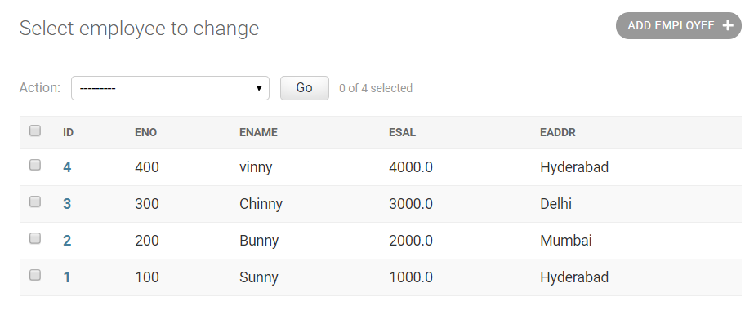
* (testapp/)> create new file ‘serializers.py’

from testapp.models import Employee

from rest_framework.serializers import ModelSerializer

class EmployeeSerializer(ModelSerializer):

class Meta:

model = Employee

fields = '__all__'

* (withrestc4/urls.py)> add

from django.contrib import admin

from django.urls import path, include

from rest_framework import routers

from testapp import views

router = routers.DefaultRouter()

#router.register('api', views.EmployeeCRUDCBV, base_name='api')

router.register('api', views.EmployeeCRUDCBV)

urlpatterns = [

path('admin/', admin.site.urls),

path("", include(router.urls))

]

* (testapp/views.py)> add

from django.shortcuts import render

from rest_framework.viewsets import ModelViewSet

from testapp.models import Employee

from testapp.serializers import EmployeeSerializer

# Create your views here.

class EmployeeCRUDCBV(ModelViewSet):

queryset = Employee.objects.all()

serializer_class = EmployeeSerializer

* <http://127.0.0.1:8000/api/> , <http://127.0.0.1:8000/api/1/> and add an employee

# model_to_dict

from django.forms.models import model_to_dict

model_to_dict(instance, fields=[field.name for field in instance._meta.fields])

# Sort Django template list

{% for key, val in dict.items|sort %}

key: {{key}} / {{value}}

{% endfor %}

# Query Dict to dict 🡨 not working

New in Django >= 1.4.

QueryDict.dict()

# Django re install db

import os

import shutil

root = os.getcwd()

parent_folders = os.listdir(root)

if "db.sqlite3" in parent_folders:

    os.remove("db.sqlite3")

else:

    ValueError("This is not django parent folder")

app_names = []

for r_f in parent_folders:

    try:

        sub1_f = os.listdir(r_f)

    except:

        continue

    if "migrations" in sub1_f:

        # delete migrations folder

        path_migrations = os.path.join(r_f, "migrations")

        try:

            shutil.rmtree(path_migrations)

            app_names.append(r_f)

        except:

            ValueError("Cant remove folder %s" %(str(path_migrations)))

# create migrations

apps = " ".join(app_names)

os.system("python manage.py makemigrations %s"%(apps))

os.system("python manage.py migrate")

os.system("python manage.py createsuperuser --username admin --email admin@example.org")

os.system("python manage.py runserver")

# Errors

## Sqlite 3.8.* above required

As this was about Centos7, you can use the Fedora package to upgrade the Centos sqlite package:

wget https://kojipkgs.fedoraproject.org//packages/sqlite/3.8.11/1.fc21/x86_64/sqlite-3.8.11-1.fc21.x86_64.rpm

sudo yum install sqlite-3.8.11-1.fc21.x86_64.rpm

# Streamlit

## Documentation

<https://docs.streamlit.io/library/get-started>

Github [code](https://github.com/Harsh1347/Streamlit)

YouTube [Video](https://www.youtube.com/watch?v=UN4DaSAZel4&list=PLuU3eVwK0I9PT48ZBYAHdKPFazhXg76h5)

## Installation

* + - * + Install streamlit



* + - * Streamlit hello

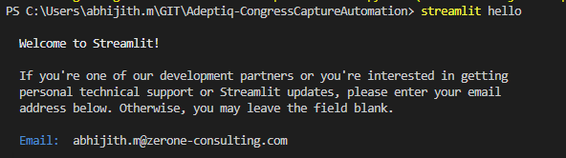

## Hello world

import streamlit as st  
  
st.title("Hello stramlit")

* + - * streamlit run test.py

## text

import streamlit as st  
  
st.title("Hello stramlit")  
st.header("Header")  
st.subheader("SubHeader")  
st.text("This is my paragraph")

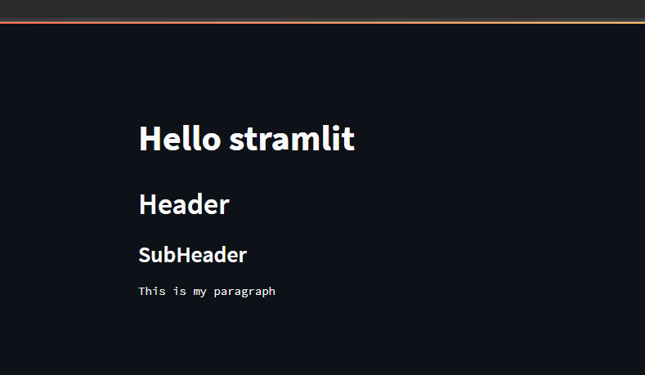

## markdown

<https://docs.streamlit.io/library/api-reference/text/st.markdown>

<https://github.com/adam-p/markdown-here/wiki/Markdown-Cheatsheet>

### write – writes module

st.write(sum, pow)

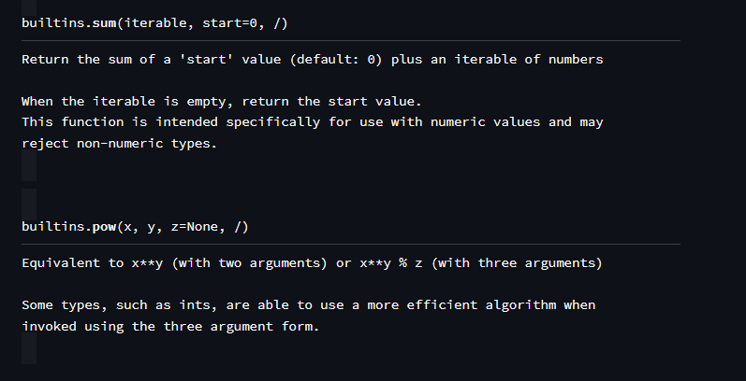

## Display Data

Github [code](https://github.com/Harsh1347/Streamlit)

import streamlit as st  
import pandas as pd  
import numpy as np  
import time  
  
a = [1,2,3,4,5,6,7,8]  
n = np.array(a)  
nd = n.reshape((2,4))  
dic = {  
 "name":["harsh","Gupta"],  
 "age":[21,32],  
 "city":["noida","delhi"]  
}  
  
data = pd.read_csv("data//Salary_Data.csv")  
  
st.dataframe(data,width=500,height= 500)  
st.table(dic)  
st.json(dic)  
st.write(dic)  
  
@st.cache  
def ret_time(a):  
 time.sleep(5)  
 return time.time()  
  
if st.checkbox("1"):  
 st.write(ret_time(1))  
  
if st.checkbox("2"):  
 st.write(ret_time(2))

## Grid

from st_aggrid import GridOptionsBuilder, AgGrid, GridUpdateMode, DataReturnMode